Newcastle Marine Modellers Association
Members Stock List April 2021

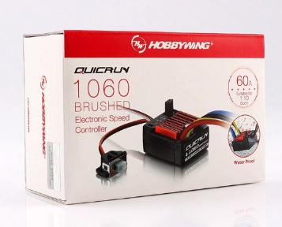
Speed Controllers $32
Water-proof and dust-proof.
Fwd/Rev/Br running mode fits for various vehicles (Fwd =Forward, Br=Brake, Rev=Reverse). (WE NEED TO SET FOR F?R MODE)
set the ESC parameters with jumpers.
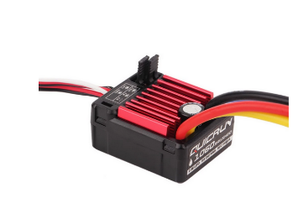
Built-in BEC BEC Output: 2A/5V (Linear Mode)
Automatic throttle range calibration, easy to use.
Multiple protections: Low voltage cut-off protection for battery / Over-heat protection / Throttle signal loss protection.
Specifications:
Model: 1060-BRUSHED
Peak Current: 60A /360A (NOTE UNDER 10 A @ 12V)
Voltage Range: 2-3S Lipo or 5-9 NiMH
Net Weight: 122g

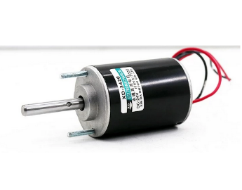
Large Motors $30.00 (inc bracket $28 w/o bracket)
3420 Motor 12V 3500rpm Permanent Magnet Motor DC Motor Adjustable Reversing Motor
Double ball bearings
12V 2400 RPM No Load 0.31A full load 2.4A
Shaft 8mm Length 71mm Dia 51 mm

Small Motors $20.00
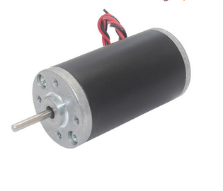
Motor Diameter: about 31mm
Motor Body Length: about 57mm
Output Shaft Diameter: about 3mm
Output Shaft Length: about 19mm
Weight: about 165g
Voltage Range: DC6V-24V
Speed: 4000rpm
Output 15 W

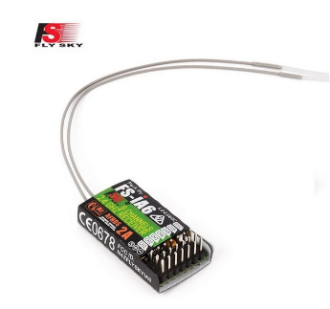
Receivers $20.00

Flysky IA6 Receiver FS-IA6/FS-IA6B/ 6CH 2.4G Dual Antenna

Item Name: FS-iA6 receiver
Channels: 6
Frequency Range :2.4-2 .48 GHz
Number of Band: 140
Transmitting Power: not more than 20dBm
Receiver Sensitivity:-105dBm
Large Servo $15.00

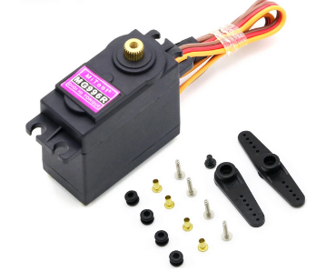
Mitoot MG996R Motor Durable Servos Digital Metal Gear

Dimension : 40mm x 19mm x 43mm
Weight : 56g
Operating Speed : 0.17sec / 60 degrees (4.8V no load)
Operating Speed : 0.13sec / 60 degrees (6.0V no load)
Stall Torque : 13 kg-cm (180.5 oz-in) at 4.8V
Stall Torque : 15 kg-cm (208.3 oz-in) at 6V
Operation Voltage : 4.8 - 7.2Volts
Gear Type: All Metal Gears
Connector Wire: Heavy Duty, 11.81" (300mm)

Small Servo $10

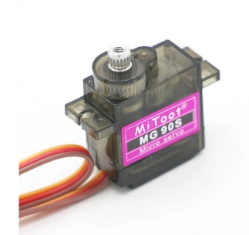
Mitoot MG90S Metal gear Digital 9g Servo SG90

Working torque: 2KG/cm
Reaction speed: 0.11 seconds / 60 degrees (4.8V
Rotation angle: 360 degrees
Servo: analog Servo
Operating voltage: 4.8V WILL BURN OUT AT 6V
Structural Material: copper metal teeth, coreless motor, double ball bearing
Size: approx. 23 x 12 x 29mm (L*W*H)
Long Servo Extensions $2.00

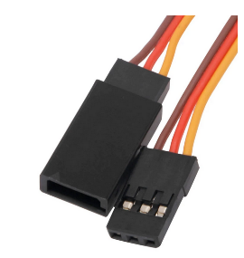
Servo Extension Lead Wire Cable For RC Futaba JR Male to Female

Length 500m

Small Servo Extensions $2.00
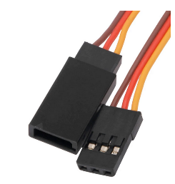
Servo Extension Lead Wire Cable For RC Futaba JR Male to Female
Length 500 mm

